Evaluation & Analysis Report

8.1 Retrieval Performance Evaluation
The retrieval stage was evaluated using Recall@5, Recall@10, Mean Reciprocal Rank (MRR), and Average Query Time. Recall measures retrieval coverage while MRR evaluates ranking quality by considering the position of the first relevant document. Average query time measures retrieval efficiency.
Retrieval Method | Recall@5 | Recall@10 | MRR | Avg Query Time (ms)
BM25 Only | 0.980 | 1.000 | 0.922857 | 0.40740
Dense Retrieval | 1.000 | 1.000 | 0.980000 | 0.01017
Hybrid Retrieval (RRF k=10) | 1.000 | 1.000 | 0.950000 | 0.41757
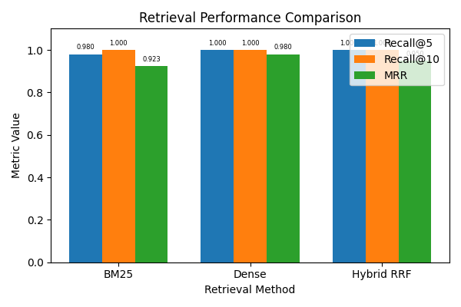
Figure 8.1: Comparison of Recall@5, Recall@10, and MRR across BM25, Dense Retrieval, and Hybrid Retrieval approaches.
As shown in Figure 8.1, all retrieval approaches achieved perfect Recall@10 performance. Dense Retrieval achieved the highest ranking quality with an MRR value of 0.98. BM25 achieved slightly lower ranking performance with an MRR of 0.922857. Hybrid Retrieval maintained perfect recall while combining lexical and semantic retrieval signals. These results indicate that Dense Retrieval and Hybrid Retrieval provide superior retrieval effectiveness compared to traditional lexical retrieval.

8.2 Cross-Encoder Threshold Optimization
To identify the optimal confidence threshold for the Cross-Encoder model, Accuracy, Precision, Recall, and F1 Score were evaluated across seven threshold values ranging from 0.50 to 0.95.
Threshold | Accuracy | Precision | Recall | F1 Score
0.50 | 0.900 | 0.957 | 0.938 | 0.947
0.60 | 0.880 | 0.957 | 0.917 | 0.936
0.70 | 0.840 | 0.955 | 0.875 | 0.913
0.80 | 0.820 | 0.953 | 0.854 | 0.901
0.85 | 0.800 | 0.952 | 0.833 | 0.889
0.90 | 0.760 | 0.950 | 0.792 | 0.864
0.95 | 0.700 | 0.946 | 0.729 | 0.824
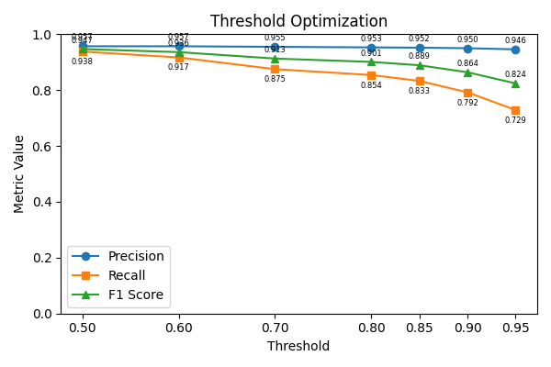
Figure 8.2: Precision, Recall, and F1 Score variation across Cross-Encoder threshold values.
Figure 8.2 demonstrates the precision-recall trade-off. Precision remains consistently high across all threshold values, while Recall decreases as the threshold increases. The highest F1 Score of 0.947 was achieved at threshold 0.50. Therefore, threshold 0.50 was selected as the optimal operating point for the final system.

8.3 Final Classification Performance
The final Cross-Encoder classification performance was evaluated using the optimal threshold value of 0.50.
Metric | Value
Accuracy | 0.900
Precision | 0.957
Recall | 0.938
F1 Score | 0.947
The model achieved an Accuracy of 90.0%, Precision of 95.7%, Recall of 93.8%, and F1 Score of 94.7%. These results indicate that the Cross-Encoder model effectively distinguishes relevant matches while minimizing classification errors.

8.4 Confusion Matrix Analysis
The confusion matrix provides a detailed view of the classification performance of the Cross-Encoder model.
 | Predicted FAQ Match | Predicted RAG Route
Actual FAQ Match | 45 | 3
Actual RAG Route | 2 | 0
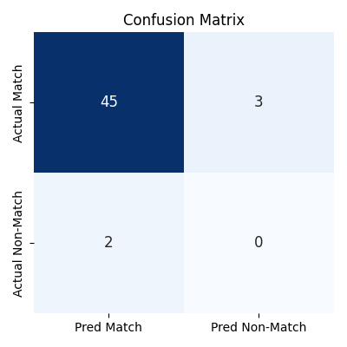
Figure 8.3: Confusion matrix visualization for Cross-Encoder classification at threshold 0.50.
The confusion matrix shows that the model correctly classified 45 relevant matches while producing only 2 false positives and 3 false negatives. The low number of classification errors confirms the effectiveness of the Cross-Encoder re-ranking model.

8.5 Semantic Retrieval Architecture
The final architecture combines sparse retrieval, dense retrieval, rank fusion, and Cross-Encoder re-ranking to maximize retrieval effectiveness and classification accuracy.

Figure 8.4: Proposed semantic retrieval pipeline integrating BM25 Retrieval, Dense Retrieval, Reciprocal Rank Fusion (RRF), and Cross-Encoder re-ranking.
The architecture first retrieves candidate documents using both BM25 and Dense Retrieval techniques. The outputs are combined using Reciprocal Rank Fusion, producing a unified ranking. The Cross-Encoder then re-ranks the top candidates based on semantic similarity. Finally, a threshold-based decision module determines whether a FAQ response can be returned directly or whether a RAG-based response should be generated. This architecture achieved Recall@10 of 1.0 and an F1 Score of 0.947 during evaluation.

8.6 Overall Findings
The evaluation results demonstrate that all retrieval approaches achieved Recall@10 of 1.0. Dense Retrieval achieved the highest ranking quality with an MRR of 0.98, while Hybrid Retrieval successfully combined lexical and semantic retrieval methods to provide robust retrieval performance. The Cross-Encoder re-ranking stage further improved decision quality and achieved an Accuracy of 90.0%, Precision of 95.7%, Recall of 93.8%, and F1 Score of 94.7% at the optimal threshold of 0.50. Based on these results, the Hybrid Retrieval + Cross-Encoder architecture is recommended as the final production solution.

